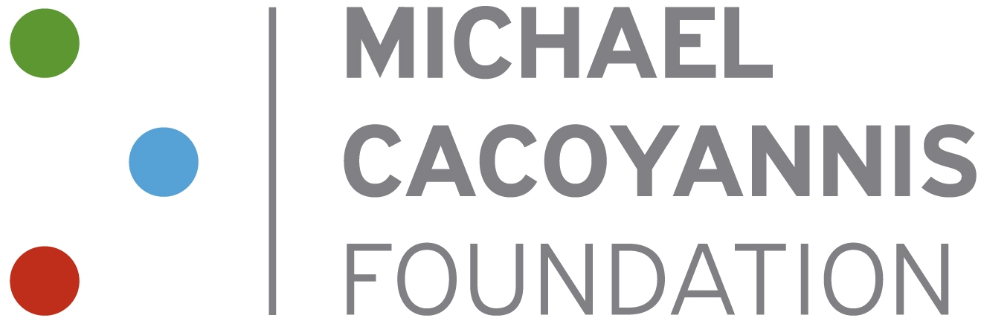 | 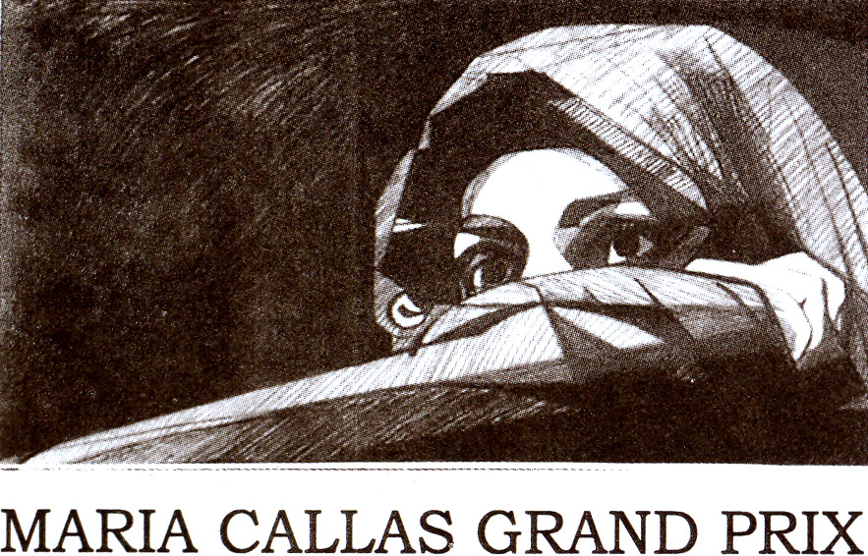 | 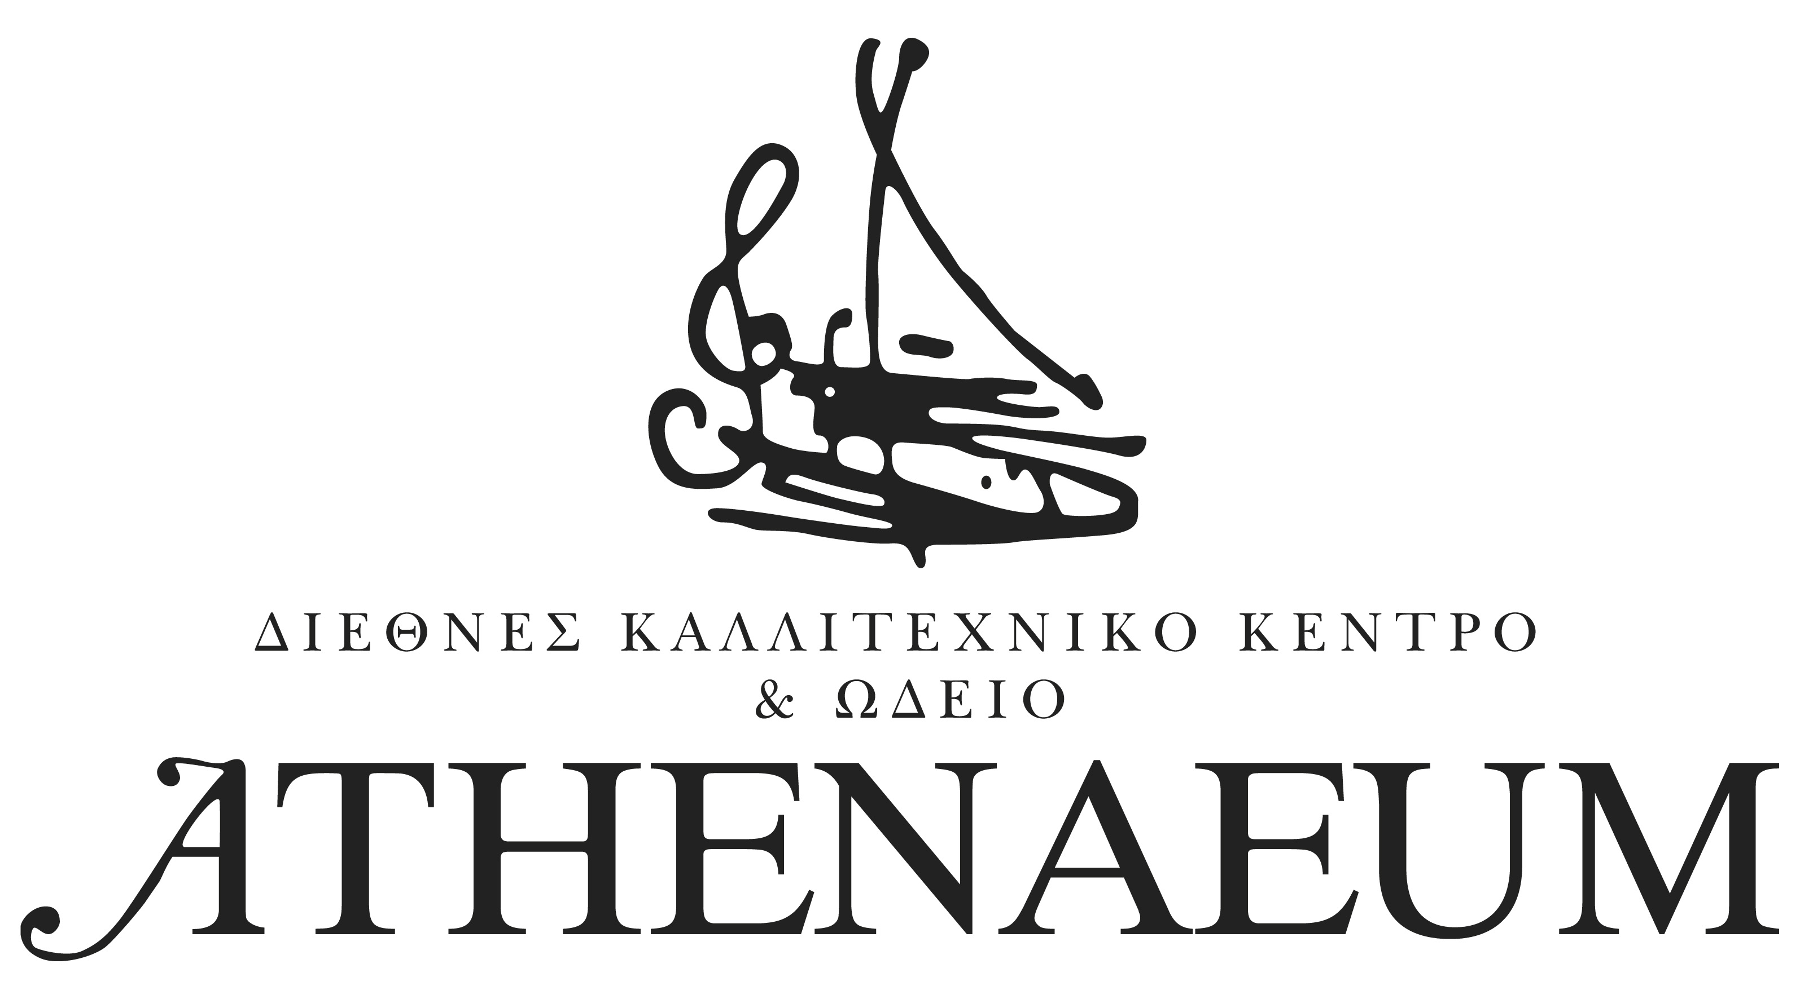

The Michael Cacoyannis Foundation
and the ATHENAEUM International Cultural Centre
are proud to announce the organization of the
38th International Maria Callas Grand Prix – OPERA
from the 4th until the 11th of October 2014

and the 39th International Maria Callas Grand Prix – PIANO in May 2015

After two years of silence the International Maria Callas Grand Prix is held again. Athens will host from the 4th till the 11th of October 2014 young talented opera singers from all over the world, who want to compete in one of the most challenging international competitions, and invites all music fans to attend the most esteemed artistic event of Greece.
Cheryl Studer will be the President of this year’s Jury Committee in Opera, that includes Sherrill Milnes, Dame Gwyneth Jones, Martina Arroyo, Christian Carlstedt -Casting Director της Bayerische Staatsoper in Munich, Peter Katona -Director of Casting of The Royal Opera (Covent Garden) and other prestigious members of the world of opera.
The 38th Maria Callas Grand Prix will be held in the venues of the Michael Cacoyannis Foundation and the Megaron-The Athens Concert Hall, with free entrance. Opera singers from all over the world can take part in the competition. The age limit for women is 31 years old and for men 33 and application must be sent by May 25th 2014. For further information you can visit the site www.athenaeum.com.gr or e-mail at contact@athenaeum.com.gr.
The Maria Callas Grand Prix is an annual cultural event with global influence. It was founded in 1975 by the International Cultural Center Athenaeum and is a member of World Federation of International Music Competitions of UNESCO. More than 1,800 artists from around the world have competed during its 37 years and many of the winners are now enjoying an international career at major opera houses and important concert halls of the world.
The organization of the Grand Prix has been approved and funded by the EU under the NATIONAL STRATEGIC REFERENCE FRAMEWORK 2007 - 2013 - Improvement of cultural services in the Region of Attica/ Operational Programme of Attica - Ministry of Culture and Sports of the Hellenic Republic.

Contact details
ATHENAEUM
3, Adrianou str., 105 55 Athens, Greece
Tel. +30 210 32 11 949, -55, -87, Fax: +30 2103211196, e-mail: contact@athenaeum.com.gr

